Digital Image Processing

Practical Exam

1. Image Processing
   1. Show the original image ‘lenna.tif’

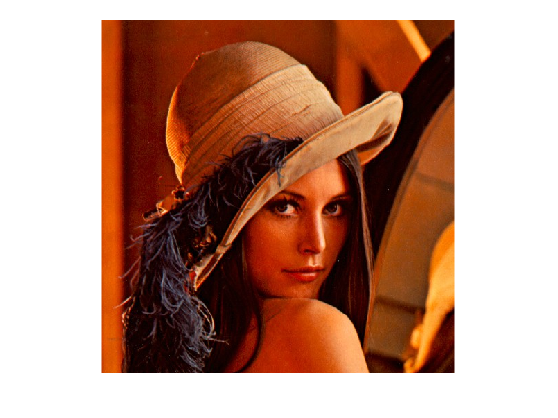

* 1. Display three components of RGB in one figure

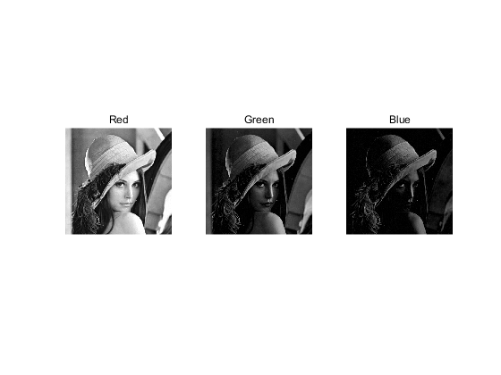

* 1. Display three components of HSI in one figure

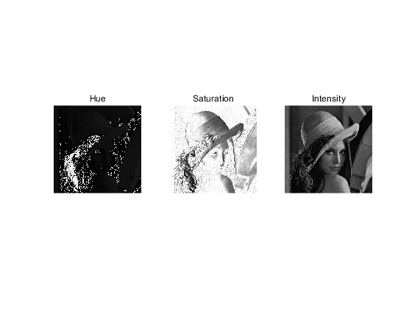

* 1. Smooth each component image of the RGB image independently using 5×5 spatial averaging mask, and combine the individually smoothed images to form the smoothed, full-color RGB result.

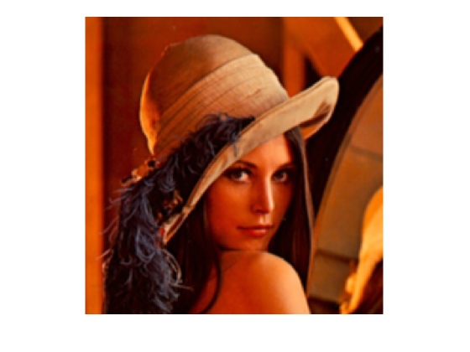

* 1. A) Smooth only the intensity component of the HSI image using 5×5 spatial averaging mask and convert the processed result to an RGB image.

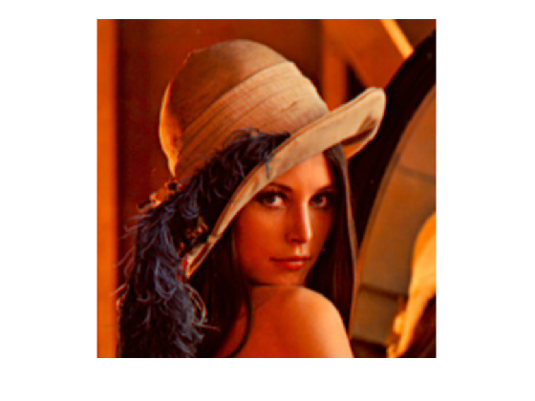

1. Show the difference between the two smoothed images.

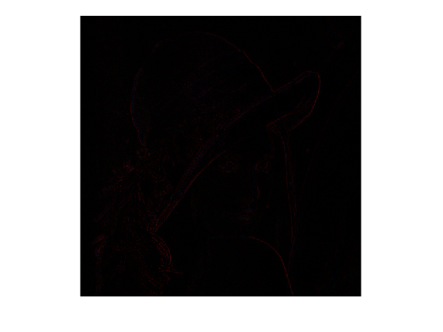

1. Draw the following function in one figure shown below

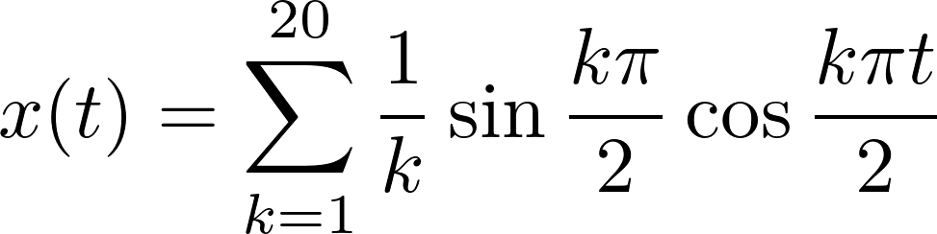

where, -5≤*t*≤5

